NODE JS
Install:
Hyper Terminal (w/ Hyper Configurations)
GIT
NodeJS

Documents:
https://nodejs.org/api/

JavaScript code has been locked and kept inside the browser. So JS has only been able to interact, request information, and add event listener to components in the browser. Basically, JS has not been able to write code for the website that is able to go beyond the boundaries of the browser. For example, JS Code is not able to reach out of the browser into the User’s computer and get access to the file system, network system, and etc.

Atom, a desktop application, needs access to the files system to load the file systems the user will edit. These applications need to write code that can interact directly with the computer independent of the browser.

NodeJS takes JS out of the browser, allowing it to interact directly to the hardware of the computer. With NodeJS, it allows us to write JS Code not just in the browser/website but also full applications that work in the computer.

REPL (Read – Evaluation – Print – Loop)
Activate (via Hyper Terminal/ Windows Powershell): $ node
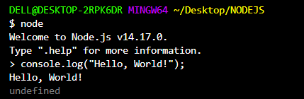

Using: fs.copyFileSync(src, dest[, mode])
- //jshint esversion:6
- const fileSync = require("fs");

- fileSync.copyFileSync("text1.txt", "text2.txt");
Line 01 is needed if this notification below is seen. If not, then you are good without it.
Line 02 Synchronously copy src (text1.txt) to destination (text2.txt).
Execute via Hyper Terminal:
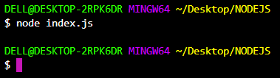
$ node index.js Tell node to execute file index.js
When you see a prompt after telling node to execute the file, it means your file has successfully ran.
Lesson: We have successfully used JavaScript code to access the hardware of the computer via NodeJS.

NPM (Node Package Manager)
https://www.npmjs.com/
NPM are external package managers which anybody can build, share, and incorporate into their websites.
NPM is bundled with node. So once you installed node, NPM is already available.
Once again, make sure you are in the correct directory.

Hyper Terminal:
$ npm init Initializes NPM
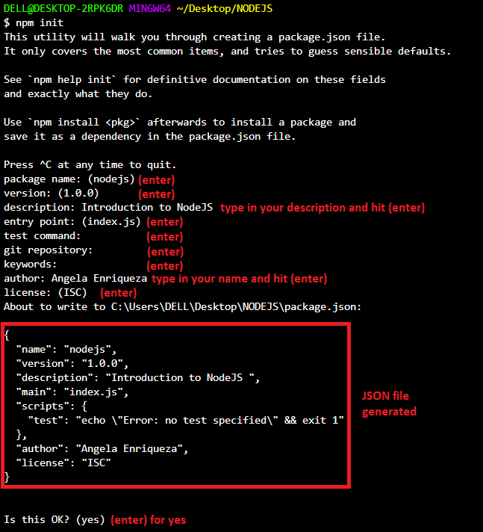
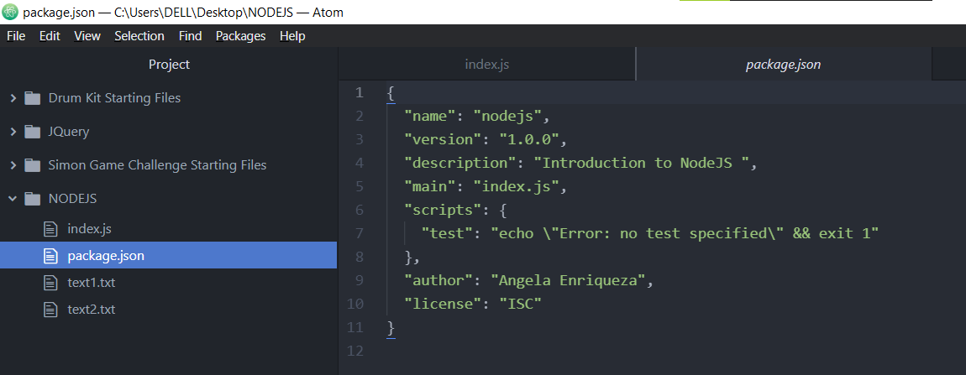
Once you start installing external packages / NPM external module, it will appear in package.json file you have created.
JSON is simply a file format to organize data and looks a little bit more like a JavaScript object.

Installing NPM
Sample Package: https://www.npmjs.com/package/superheroes
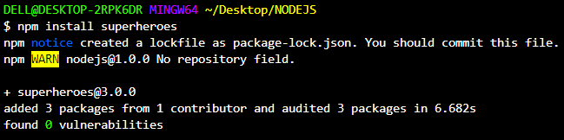
After successful installation:
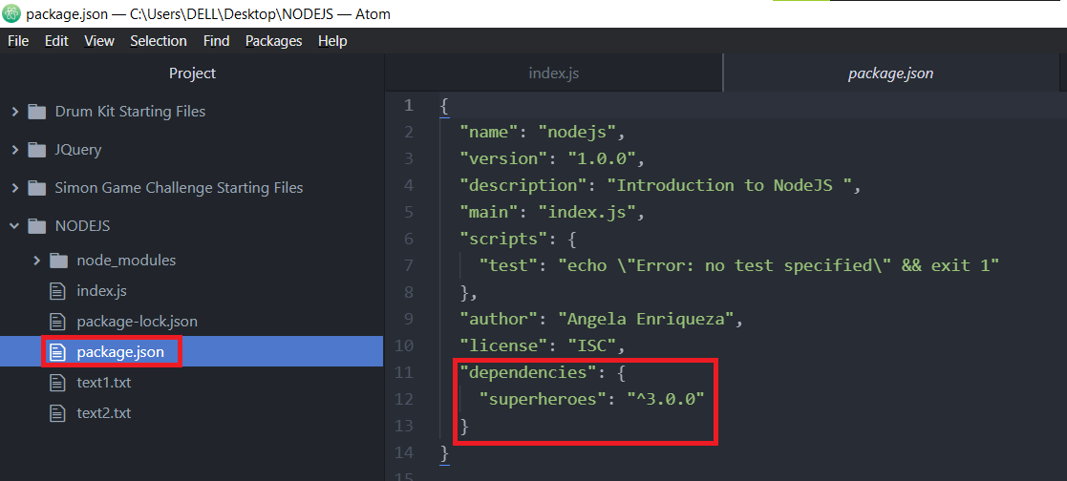
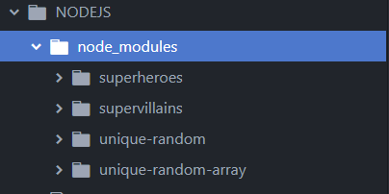
Under your node_modules folder, it will show you your external and internal packages of your project.

EXPRESS
Documentation: http://expressjs.com/

How to Install Express
Link: http://expressjs.com/en/starter/installing.html
- Node.js must already be installed.
- Create directory to hold your application. Don’t forget the JavaScript file as well.
- Make sure you are in the directory.
- Initialize NPM: (via Hyper) $ npm init
- Make JavaScript file as the entry point.
- Install Express: (via Hyper) $ npm install express
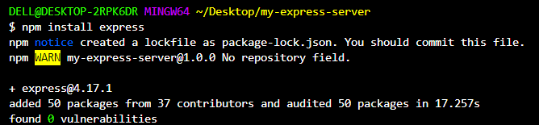

Once Express is successfully installed, your application will have node_modules that Express requires (including Express itself) and your .json file will have a dependency.
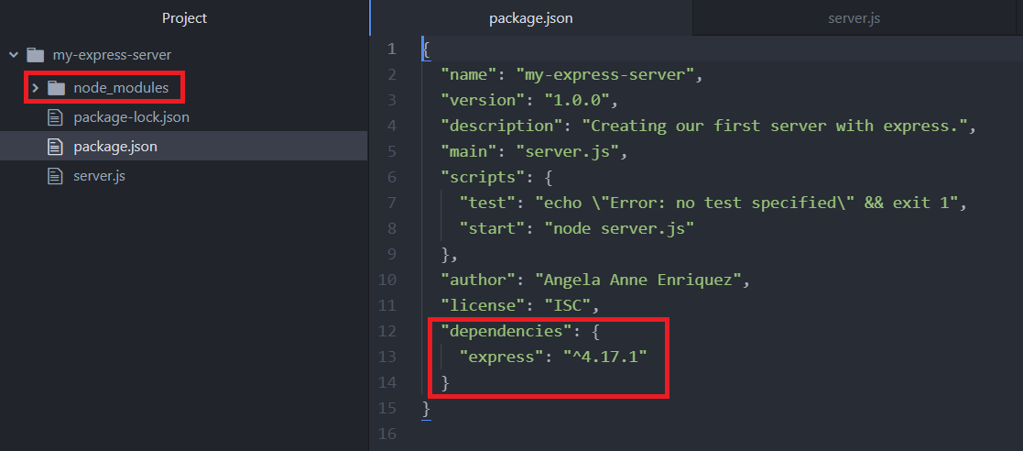
Installing Nodemon
Nodemon restarts your server everytime you save your files.
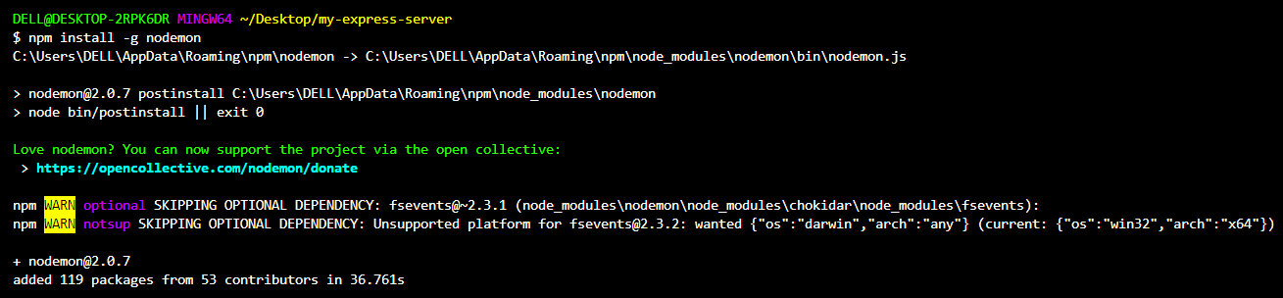

Integrating HTML Files to NodeJS
- const express = require("express");
- const app = express();
- const port = 3000;

- app.get("/", (req, res)=> {
- res.sendFile(__dirname + "/index.html");
- });

- app.post("/", (req, res)=> {
- res.send("Thanks for posting that!")
- });

- app.listen(port, ()=> {
- console.log("Port 3000 running.");
- });
Line 06: __dirname returns the file path of the current file no matter where it is hosted.
Line 09: Processes post request after the form is submitted.

Processing POST request via Body-Parser
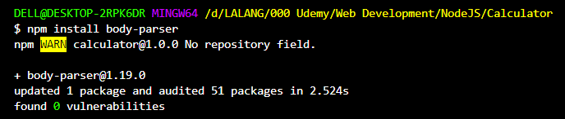
Allow us to parse the information we get from the information sent and access the properties and variables to manipulate for our program.

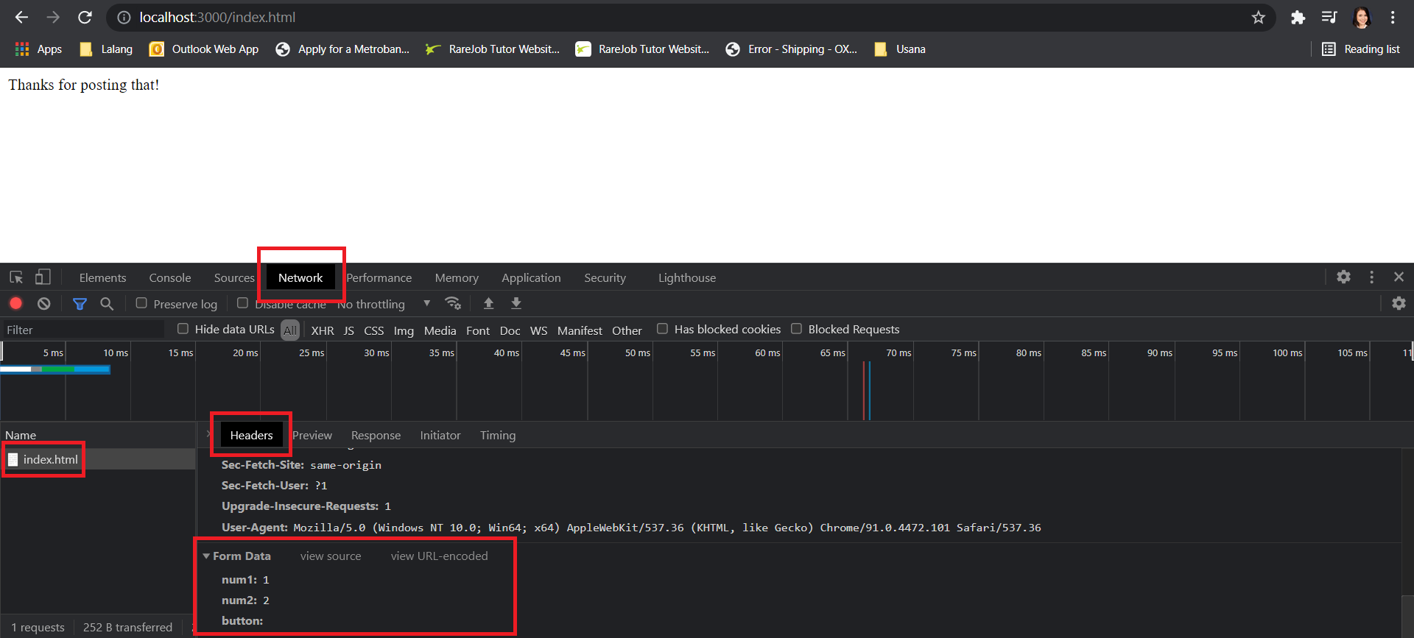
To confirm if the package has been successfully installed: Check your package.json file for its dependencies. 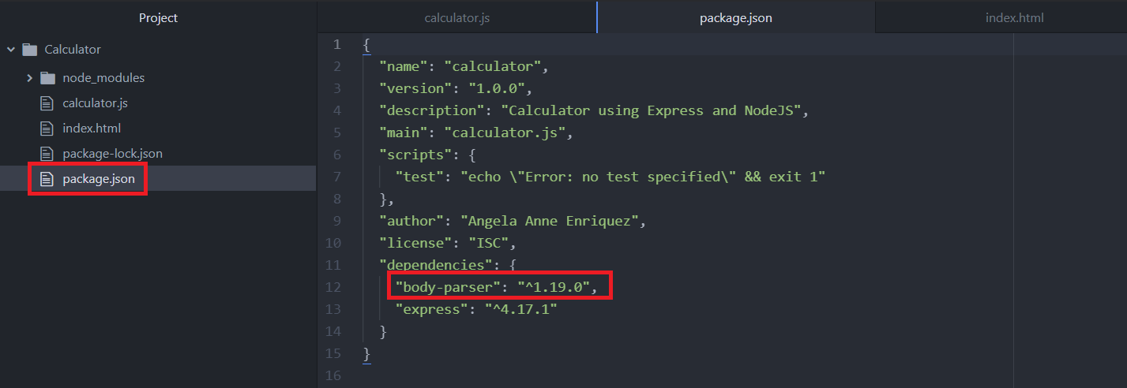

jkajsdflkjaskdf

